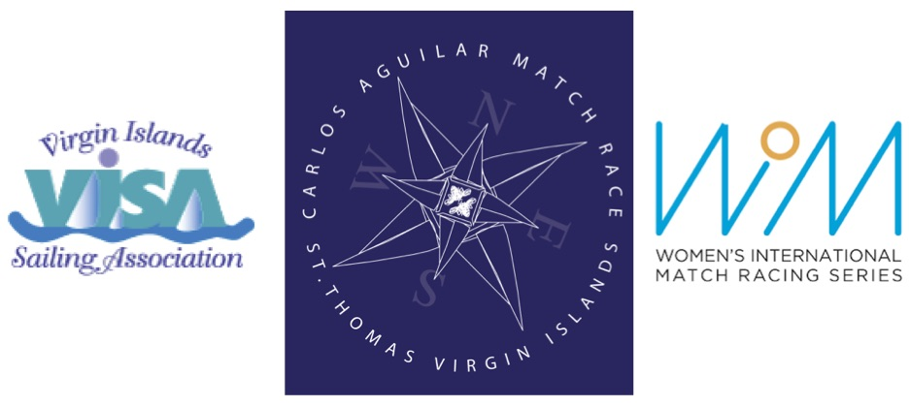

2016 CARLOS AGUILAR MATCH RACE

Virgin Islands Sailing Association

Women’s Match Race

Racing Days: 01 - 04 December 2016

Registration and Practice Sailing: 29 – 30 November 2016

REQUEST FOR INVITATION
(Please submit by 30 September 2016)

I would like an invitation to the 2016 Carlos Aguilar Match Race:

Name:

Address:

City, State, Postcode:

Country:

Home Phone:

Work/Cell Phone:

E-mail:

World Sailing Sailor ID:

To submit request, please complete this form and e-mail to Verian Tuttle verianaguilar1@gmail.com and cc Liz Baylis liz@wimseries.com

